IFE›

Software Engineering

Lab 1 – 4: Requirements Analysis & UML Design

Smart College Helpdesk
AI-Powered Management System

Prepared by: Arthi I (Erasmus student)
Host university -- Lodz University of Technology
Home university --Karunya institute of technology and science
Course: Software Engineering
April 2026

Revision History
Name | Date | Reason for Changes | Version
Arthi I | 02/04/2026 | Initial version — Lab 1 SRS | 1.0
Arthi I | 13/04/2026 | Added use case diagram — Lab 2 | 2.0
Arthi I | 20/04/2026 | Added class diagram — Lab 3 | 3.0
Arthi I | 26/04/2026 | Added sequence diagram — Lab 4 | 4.0
Arthi I | 30/04/2026 | Final consolidated overview | 5.0

LAB 1 — Requirements Analysis

1. Introduction

1.1 Purpose
This Software Requirements Specification (SRS) document defines the functional and non-functional requirements for the Smart College Helpdesk AI-Powered Management System, Version 1.0. The system digitises and automates the student complaint management workflow at Karunya Institute of Technology and Sciences. This document follows the IEEE 830-1998 standard and acts as a contract between developers, testers, and academic evaluators.

1.2 Document Conventions
Requirements use the format FR-XX (functional) and NFR-XX (non-functional) with unique IDs for traceability. The word "shall" denotes mandatory requirements. Priority levels are High (H), Medium (M), and Low (L).

1.3 Intended Audience
- Developers: Sections 3, 4, and 5 — technical specifications and constraints.
- Testers: Section 5 (functional) and Section 6 (non-functional) — testable criteria.
- Academic Evaluators: Sections 1, 2, and Appendix — holistic overview and UML diagrams.
- System Administrators: Section 2.4 — operating environment and hardware/software interfaces.

1.4 Product Scope
The Smart College Helpdesk is a web-based complaint management platform. Students submit grievances digitally; an embedded AI engine (GPT-3.5-turbo) automatically categorises and prioritises each complaint. Staff receive organised department queues; administrators gain institution-wide oversight. The system eliminates manual triage, reduces resolution time, and improves student satisfaction through real-time status tracking and feedback collection.

1.5 References
- OpenAI. GPT-3.5 Turbo API Documentation. https://platform.openai.com/docs/
- Flask Documentation. https://flask.palletsprojects.com/
- SQLAlchemy ORM Documentation. https://www.sqlalchemy.org/
- IEEE Std 830-1998 — Recommended Practice for Software Requirements Specifications.
- Python Software Foundation. https://docs.python.org/3/

2. Overall Description

2.1 Product Perspective
The Smart College Helpdesk is a standalone, self-contained three-tier web application: a browser-based frontend (HTML5/CSS3/Jinja2), a Python Flask backend, and an SQLite relational database. It interfaces with an external LLM API (GPT-3.5-turbo) for AI classification and is deployed on an institutional server accessible over the campus network or internet.

2.2 Product Features
- AI-powered automatic complaint classification into 6 departments and 3 priority levels
- Role-based dashboards for Students, Staff, and Administrators
- Real-time complaint status tracking: Waiting → In Progress → Resolved
- Post-resolution feedback collection (5-star rating + optional comment)
- Secure authentication with Flask-Login and session management
- Responsive web interface compatible with desktop and mobile browsers

2.3 User Classes and Characteristics
User Class | Description | Access Level
Student | Staff | Administrator

2.4 Operating Environment
- Server OS: Ubuntu 20.04 LTS or Windows Server 2019
- Python 3.8+, Flask 2.x, SQLAlchemy 1.4+
- Database: SQLite 3 (upgradable to PostgreSQL for production)
- Client: Chrome 90+, Firefox 88+, Safari 14+, Edge 90+
- Network: Internet access required for LLM API calls
- Hardware: Minimum 2 GB RAM, 2-core CPU, 10 GB storage

2.5 Constraints
- AI classification must use the OpenAI API; no on-premise ML training.
- Database layer must use SQLAlchemy ORM (prevents SQL injection).
- Frontend rendered via Flask Jinja2 templates only.
- All form inputs validated both client-side and server-side.
- API keys stored as environment variables — never hardcoded.

3. Functional Requirements
The following requirements define WHAT the system shall do. Each requirement is Specific, Measurable, Attainable, Relevant, and Traceable (SMART). Every requirement uses "shall" to denote a mandatory engineering obligation.

FR-01 to FR-05 — Complaint Submission
ID | Requirement
FR-01 | The system shall validate that submitted complaint text is non-empty and between 10 and 2,000 characters before processing.
FR-02 | The system shall send the validated complaint text to the AIClassifier module within 500 milliseconds of successful validation.
FR-03 | The system shall store each complaint with its assigned category, priority level, and submission timestamp in the database.
FR-04 | The system shall display a unique complaint ID and current status to the student immediately after successful submission.
FR-05 | Upon AI API failure, the system shall apply keyword-based fallback classification and log the error — the complaint shall still be stored.

FR-06 to FR-10 — AI Classification
ID | Requirement
FR-06 | The AIClassifier shall classify complaint text into one of six categories: Finance, Academic Support, Technical Support, Hostel Management, Library Services, or General Queries.
FR-07 | The AIClassifier shall assign one of three priority levels — High, Medium, or Low — based on urgency keywords in the complaint text.
FR-08 | The AIClassifier shall use few-shot prompting with at least two examples per category to improve classification accuracy.
FR-09 | The AIClassifier shall return a structured JSON response containing 'category' and 'priority' fields.
FR-10 | AI classification shall complete within 2 seconds under normal API response conditions.

FR-11 to FR-16 — Role-Based Access Control
ID | Requirement
FR-11 | The system shall authenticate users using email and hashed password; plain-text passwords shall never be stored.
FR-12 | Upon successful login, the system shall redirect each user to their role-specific dashboard (Student / Staff / Admin).
FR-13 | Students shall only be permitted to view their own submitted complaints.
FR-14 | Staff shall only be permitted to view and update complaints assigned to their department.
FR-15 | Administrators shall have read and write access to all complaints and user records.
FR-16 | Upon an unauthorised access attempt, the system shall return HTTP 403 and redirect to the login page.

FR-17 to FR-20 — Status Tracking & Feedback
ID | Requirement
FR-17 | The system shall display the current status of each complaint on the student dashboard in real time.
FR-18 | Staff shall be able to update complaint status to 'In Progress' or 'Resolved'; all transitions shall be logged with timestamp and staff ID.
FR-19 | Upon status change to 'Resolved', the system shall unlock the feedback submission form for the relevant student.
FR-20 | The feedback form shall accept a mandatory star rating (1–5) and an optional comment (max 500 characters); data shall be stored linked to the complaint ID and student ID.

4. Non-Functional Requirements
Non-functional requirements define HOW WELL the system performs. Each includes a measurable threshold following the SMART criteria from the lab.

NFR-01 to NFR-04 — Performance
ID | Requirement
NFR-01 | The system shall process complaint submission (excluding AI API latency) within 2 seconds.
NFR-02 | Dashboard page load time shall not exceed 1 second for datasets of up to 1,000 complaints.
NFR-03 | End-to-end AI classification (including API call) shall complete within 3 seconds under normal network conditions.
NFR-04 | The system shall support at least 50 concurrent user sessions without performance degradation.

NFR-05 to NFR-09 — Security
ID | Requirement
NFR-05 | All database queries shall be executed through SQLAlchemy ORM to prevent SQL injection attacks.
NFR-06 | All HTML output shall be auto-escaped via Jinja2 to prevent Cross-Site Scripting (XSS).
NFR-07 | User passwords shall be stored using bcrypt hashing with a minimum cost factor of 12.
NFR-08 | API keys and secrets shall be stored as environment variables and shall never appear in source code.
NFR-09 | Session tokens shall expire after 30 minutes of inactivity.

NFR-10 to NFR-12 — Reliability & Maintainability
ID | Requirement
NFR-10 | The system shall maintain 99% uptime during academic term periods.
NFR-11 | On AI API failure, the system shall fall back to rule-based classification without crashing.
NFR-12 | The codebase shall follow a modular MVC structure; all AI logic shall be encapsulated in a standalone AIClassifier module to allow easy replacement.

LAB 2 — Use Case Diagram

5. Use Case Diagram
The use case diagram identifies the actors interacting with the Smart College Helpdesk system and the functional actions they can perform. Standard UML notation is used throughout.

5.1 Actors
Actor | Role
Student | Primary end-user. Registers, logs in, submits complaints, tracks status, gives feedback.
Staff | Departmental personnel. Views queue, updates complaint status, resolves complaints.
LLM API | External AI service. Called by AIClassifier to classify and route complaints.

5.2 Use Case Relationships
Relationship | Type | Explanation
Submit → Classify | «include» | Every complaint submission automatically triggers AI classification — mandatory step.
Classify → Route | «include» | Classification always includes routing to the correct department queue.
Login → Invalid Credentials | «extend» | If login fails, the Invalid Credentials notification is shown — optional/conditional path.
Resolve → Submit Feedback | «extend» | On complaint resolution, the student may optionally submit feedback — not mandatory.
Student / Staff → Login | Generalisation | Both Student and Staff specialise from a common User actor who performs Login.

5.3 Use Case Diagram
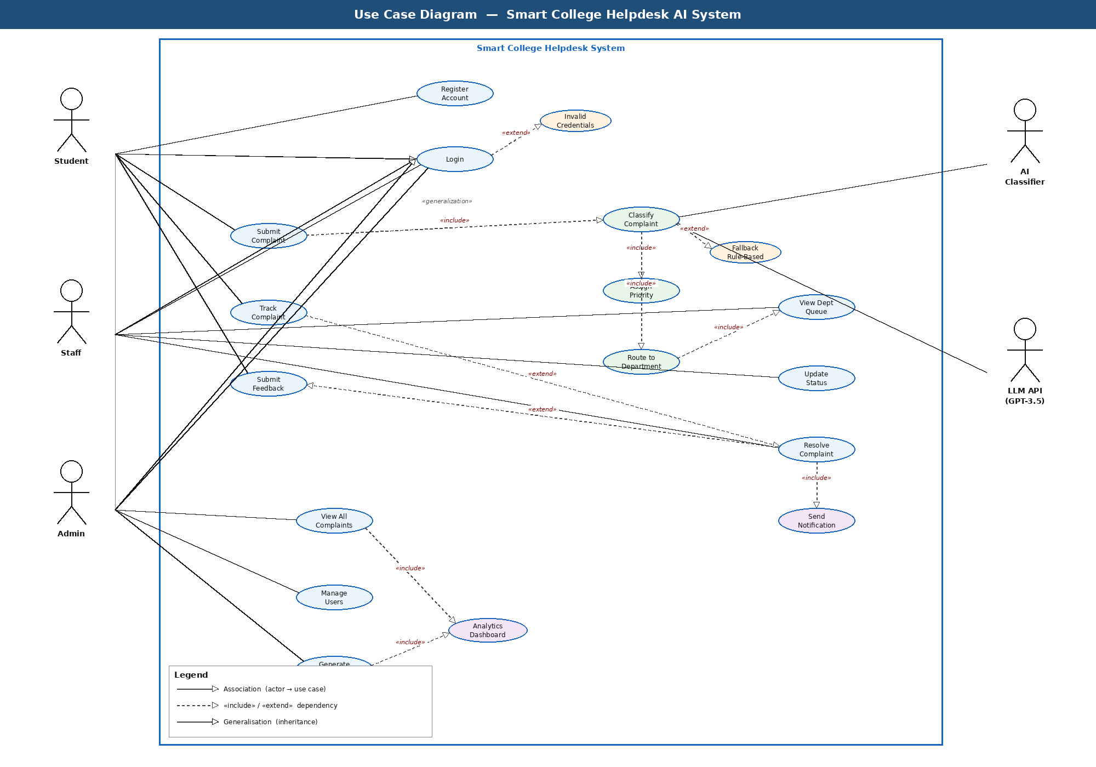

LAB 3 — Class Diagram

6. Class Diagram
The UML Class Diagram below models the object-oriented design of the Smart College Helpdesk system. Five or more classes are implemented, incorporating the key OOP relationships required by the lab: Inheritance, Composition, Aggregation, and Association.

6.1 Classes and Roles
Class | Role | Key Attributes / Methods
User (abstract) | Base entity | userId, username, email, passwordHash, role | login(), logout()
Student | Complaint creator | studentId, department, yearOfStudy | submitComplaint(), submitFeedback()
Staff | Queue handler | staffId, assignedDept | updateStatus(), resolveComplaint()
Administrator | System overseer | adminId, adminLevel | generateReport(), manageUsers()
Complaint | Core entity | complaintId, content, status, priority, submittedAt | updateStatus(), assignTo()
AIClassifier | AI engine | modelName, apiEndpoint | classify(), assignPriority(), buildPrompt()
Feedback | Rating entity | feedbackId, rating, comment | submit(), getRating()
Department | Routing entity | deptId, deptName, headOfDept | getQueue(), getStaffList()

6.2 OOP Relationships
Type | From | To | Explanation
Inheritance (is-a) | Student / Staff / Admin | User | All three extend abstract User, sharing login and profile behaviour.
Composition (owns) | Complaint submission | AIClassifier | AIClassifier is created and owned within the submission process; cannot exist independently.
Aggregation (has) | Complaint | Feedback | A Complaint may have 0..* Feedback objects; Feedback can exist independently in the database.
Association (submits) | Student | Complaint | A Student submits 1..* Complaints; both have independent lifecycles.
Association (manages) | Staff | Complaint | Staff members update and resolve Complaints in their department queue.
Association (routed to) | Complaint | Department | Each Complaint is classified and routed to exactly one Department.
Association (belongs to) | Staff | Department | Each Staff member belongs to one Department determining their complaint queue.

6.3 Class Diagram
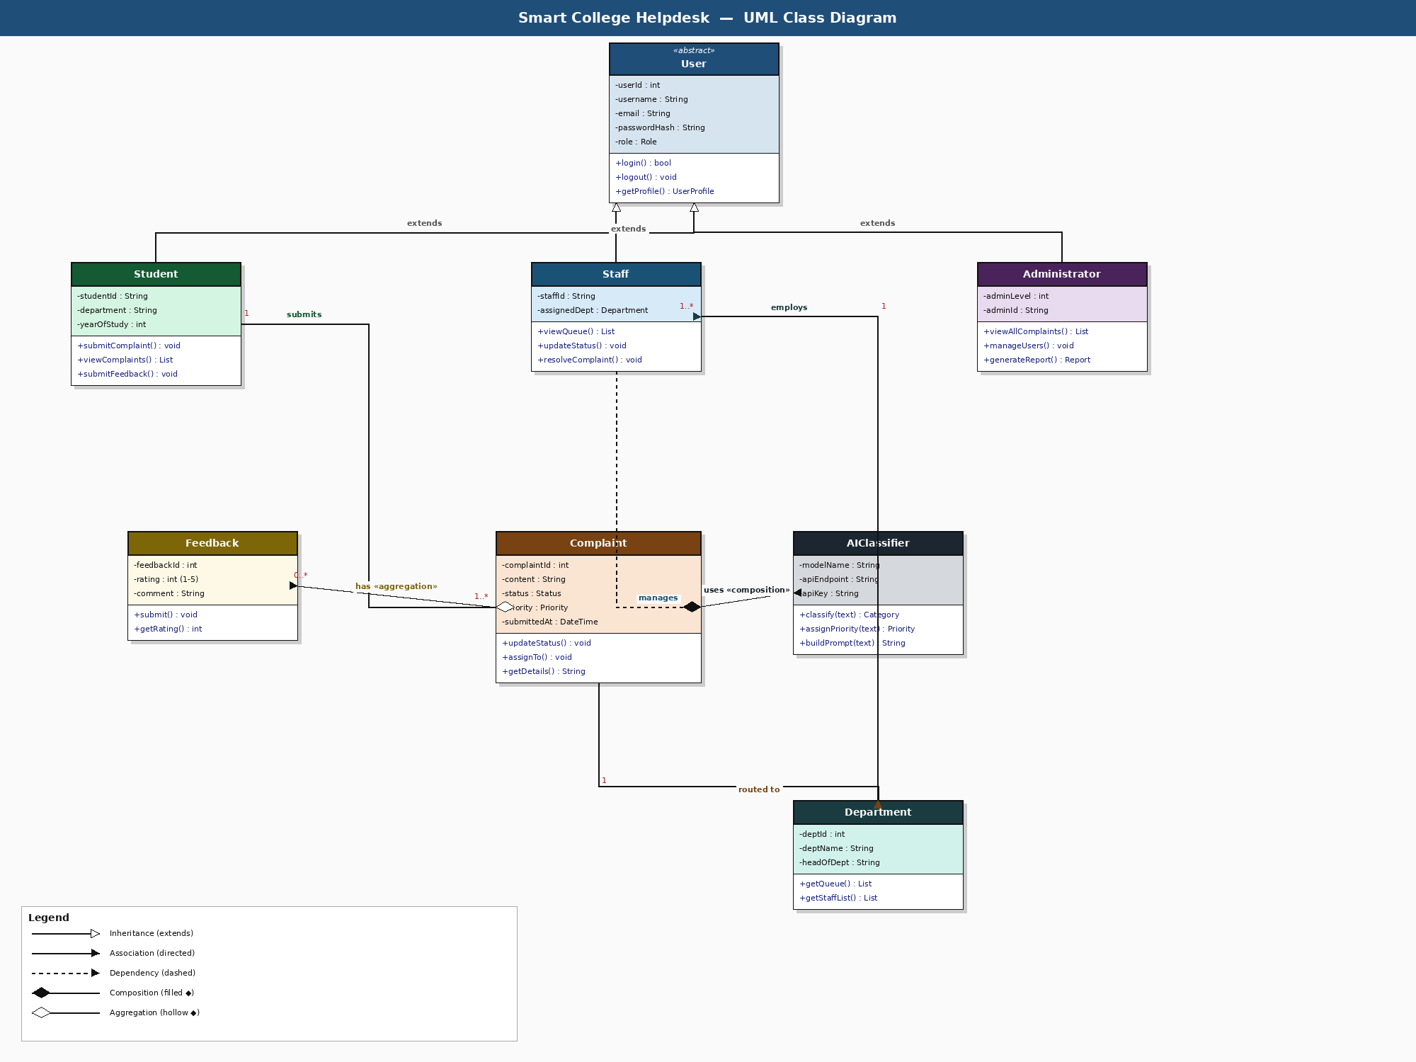

LAB 4 — Sequence Diagram

7. Sequence Diagram
The sequence diagram models the time-ordered message flow for the primary use case: a student submitting a complaint. It shows interactions across all five system lifelines.

7.1 Lifelines
Lifeline | Responsibility
Student | Initiates the complaint submission and receives confirmation.
Browser (Frontend) | Renders the form via Jinja2 and sends HTTP requests to Flask.
Flask Backend | Validates input, orchestrates AIClassifier call, persists data, returns response.
AIClassifier | Builds prompt, calls LLM API, parses JSON response.
LLM API / DB | GPT-3.5-turbo returns category+priority JSON; SQLite stores the complaint.

7.2 Message Flow
Step | Actors | Description
1–4 | Student ↔ Browser ↔ Flask | Student opens complaint form; GET request returns Jinja2-rendered HTML.
5–6 | Browser → Flask | Student fills and submits form; Browser POSTs complaint text to /submit.
7–10 | Flask → AIClassifier → LLM | Flask calls classify(text); AIClassifier builds prompt, calls GPT-3.5-turbo, parses JSON {category, priority}.
11–12 | Flask → SQLite DB | Classified complaint is stored with category, priority, and timestamp; complaintId returned.
13–14 | Flask → Browser → Student | Confirmation page with unique complaint tracking ID is rendered and displayed.
15–16 | Flask → Staff Dashboard | Complaint is routed to the relevant department staff queue via DB update.

7.3 Sequence Diagram
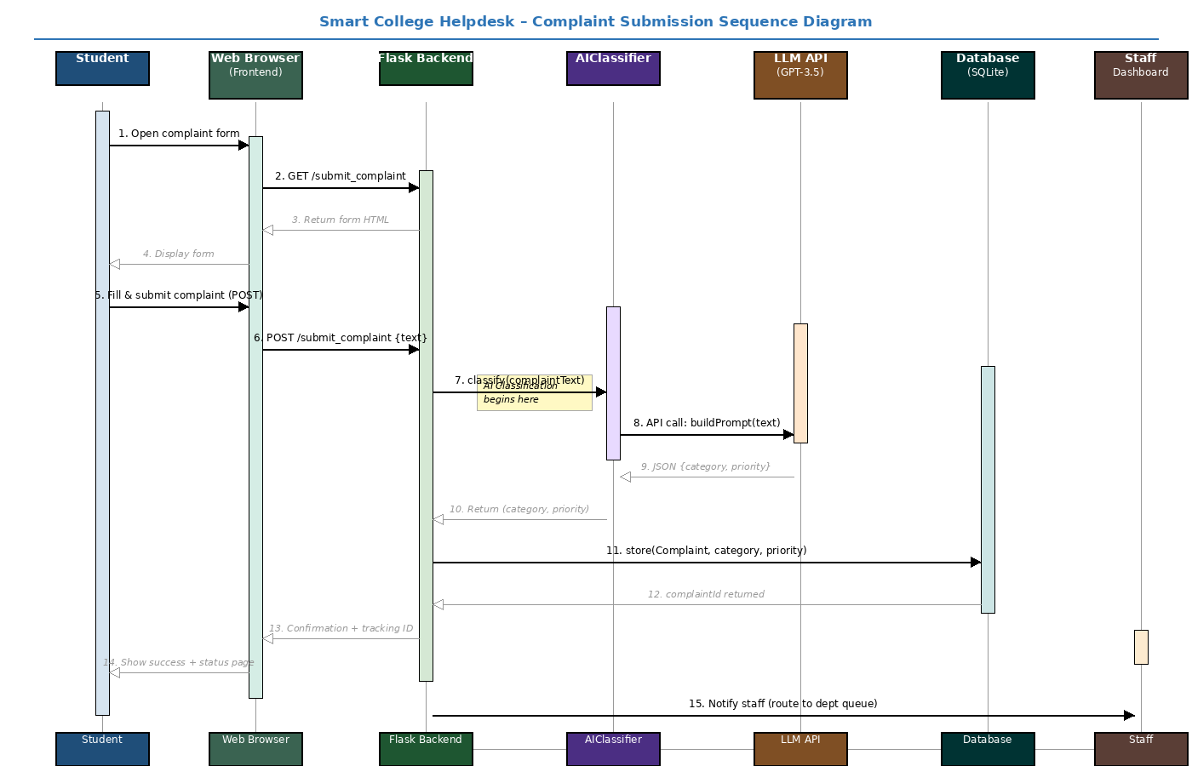

Supporting Material — External Interfaces

8. External Interface Requirements

8.1 Key Screens (UI)
- Login / Registration — email + password form with inline validation.
- Student Dashboard — complaint list with status badges and New Complaint button.
- Complaint Form — free-text area; no manual category selection required.
- Staff Queue View — filterable list with status update controls.
- Admin Panel — system-wide table, user management, summary statistics.
- Feedback Page — star-rating widget + comment field, shown post-resolution.

8.2 Software Interfaces
Component | Version | Purpose
Python Flask | 2.x | Web framework — routing, templates, session management
SQLAlchemy ORM | 1.4+ | Database abstraction and SQL injection prevention
SQLite | 3.x | Persistent relational data storage
OpenAI API | GPT-3.5-turbo | Complaint classification and department routing
Flask-Login | 0.6+ | Authentication and RBAC session management
Jinja2 | 3.x | HTML templating with automatic XSS escaping

